# ***TMI Project: FINGERPRINT SENSING***

**TEAM MEMBERS:-**

1. Aryan Singh (Geological Technology) - 23410008
2. Megha Agrawal (BSMS Physics) - 23324011
3. Monika Choudhary( Chemical Engineering) -23112064
4. Shruti(Geophysical Technology) - 23411036

# ***Fingerprint-Based Biometric Attendance System***

**Project Description:-**

* In this project, we used the fingerprint Module and Arduino to take and keep attendance data and records.
* Biometric Attendance system has a wide application in schools, colleges, business organizations, and offices where marking of attendance is required accurately with time.
* By using the fingerprint sensor, the system will become more secure as it helps in uniquely identifying the users.
* Fingerprint scanners can be used in one of two ways, for verification or identification.

**Materials Required -**

# Arduino UNO R3 board with DIP ATmega328P

# Robo Pixe LCD 16x2 Alphanumeric Display for 8051, AVR, Arduino, PIC, ARM Al

# DS3231 AT24C32 IIC Precision RTC

# Embeddinator Optical Finger Print Sensor Module R307

# Electronic Spices NO switch 11x11x4.3MM 4PIN Tactile Tact Push Button Micro Switch Direct Plug-in Self-Reset DIP Top Copper pack of 10

# Electronic Spices 10 Pcs Mini 2 Pin SPST ON/OFF HIGH-performance Switch For Electronic Circuit PCB, For electronic project or experiment

# Duracell Specialty Type 2025 Lithium Coin Camera Battery, pack of 1

1. YUV'S Jumper Wires Male To Male, Male To Female, Female To Female/Breadboard Jumper Wires (40+40+40)
2. Li-Ion Rechargeable Battery
3. Electronic Spices 5V Passive Buzzer Acoustic Component Mini Alarm Speaker
4. Red LED-5mm Diffused – 10 Pieces Pack

# Nakoda 555 Innova Plastic Container for Home Storage - 1000 ml

Total budget- 5500 rupees

**ABOUT THE PROJECT: -**

In this project, we will design a Fingerprint Sensor Based Biometric Attendance System using Arduino. Simply we will be interfacing fingerprint sensor with Arduino, LCD Display & RTC Module to design the desired project. We used the fingerprint Module and Arduino to take and keep attendance data and records. The Fingerprint Sensor module authenticates a true person or employee by taking their finger input in the system. Here we are using 4 push buttons to register a new fingerprint or delete a stored fingerprint or match a stored fingerprint. The 4 push buttons are used as an input unit for these tasks. Similarly, RTC Module DS3231 is used for registering scanning/entering/existing time of the user.

The LCD displays the time record and every function happening via the push button. The buzzer indicates different functions and happening whenever an interrupt is detected. The LED is used for power indication.

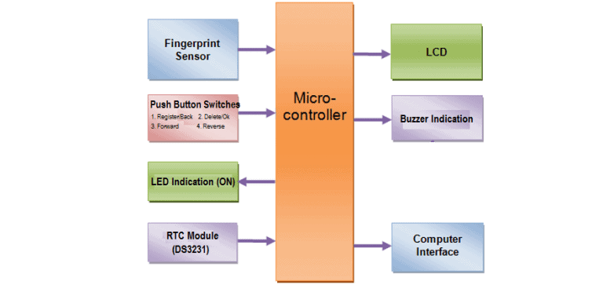

**Timeline:-**

| **Serial no.** | **Task** | **Individual contributions** | **Start date** | **End date** |
| --- | --- | --- | --- | --- |
| 1. | Research about the project and make a project proposal | Information and project details - Megha and Monika  Hardware and material research - Aryan Singh  Project proposal - Shruti | 02/09/2023 | 07/09/2023 |
| 2. | Collecting hardware and resources |  | 18/09/2023 |  |
| 3. | Starting with the circuit management |  | 26/09/2023 |  |
| 4. | Starting with code |  | 26/09/2023 |  |
| 5. | Connecting software with circuit |  | 15/10/2023 |  |
| 6. | Finalizing the project |  | 25/10/2023 |  |
| 7. | Project presentation |  |  |  |